Solar/Battery Power System

Clement Ong

Tarik Dawson

Lauren Lugo

Nathan Gil

**Concept of Operations**

REVISION – Draft

1 September 2022

Concept of Operations

for

Solar/Battery Power System

Team <16>

Approved by:

____Nathan Gil_______10/1/2022__

Project Leader Date

_____________________________

Prof. Kalafatis Date

_____________________________

T/A Date

**Change Record**

| **Rev.** | **Date** | **Originator** | **Approvals** | **Description** |
| --- | --- | --- | --- | --- |
| **0** | September 15, 2022 | [Pen-Hao Huang] |  | Draft Release |

**Table of Contents**

**Table of Contents** **3**

**List of Tables** **4**

**List of Figures** **5**

**1.** **Executive Summary 6**

**2.** **Introduction 6**

2.1. Background 6

2.2. Overview7

**3.** **Operating Concept 8**

3.1. Scope8

3.2. Operational Description and Constraints 8

3.3. System Description 8

3.4. Modes of Operations 9

3.5. Users 9

3.6. Support 9

**4.** **Scenario(s) 10**

4.1. Charging Devices in Remote Locations 10

4.2. Easier Access to Renewable Energy 10

4.3. Determining Optimal Solar Panel Positions 10

**5.** **Analysis 10**

5.1. Summary of Proposed Improvements 10

5.2. Disadvantages and Limitations 10

5.3. Alternatives 11

5.4. Impact 11

**List of Tables**

**List of Figures**

**Figure 1: Functional System Diagram………………………………………………………………….6**

**Figure 2: Topology of Solar Power Battery System……………………………………………….7**

# 

# Executive Summary

The purpose of this project is to provide easier access to generating clean energy for household devices without the need of multiple solar panels. The proposed solution is to create a functionally independent power grid capable of generating power from a solar cell system. This grid will be able to power both AC and DC consumer devices such as computers and smartphones while simultaneously charging a battery. Specifically, this will be done through Max Power Point Tracking (MPPT) to regulate the flow of voltage and current to optimize the system. Another key component will be the ability to switch to battery power in cases where the solar cells are not producing enough power. The user will be able to monitor this system and MPPT analysis using an android app and computer website.

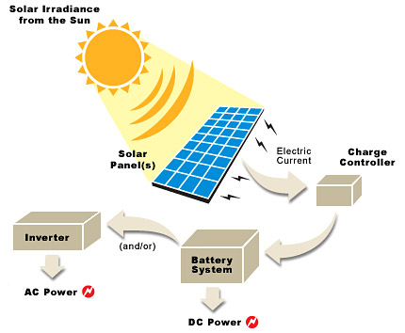

**Figure 1.** *Functional System Diagram*

# Introduction

This document is an introduction to the solar/battery power system, a system built to convert solar power into usable DC or AC electricity that is capable of charging common electronic devices. This system will be able to switch between battery power and solar power to ensure constant power delivery, making the system work even when the sun is not present. Additionally, a website will be created to display all data produced from the solar panel.This system promotes the use of renewable energy which is rapidly becoming more and more popular in society.

## Background

The Earth’s temperature is steadily increasing, eventually making it too warm to grow crops, and increasing the risk of more frequent and heavier rainfall, snowfall, and other types of precipitation. A recent example of severe precipitation was the snowstorm in Texas on February 13th which caused 4.5 million homes to be without power, resulting in the worst energy infrastructure failure in history.

As a result, a need to switch from relying on fossil fuels to relying on renewable energy has emerged due to global warming and its effects. There are many types of renewable energy sources that are being used today to make the switch from fossil fuels. Harnessing energy from the sun, known as solar power, will be our focus for this project. Solar energy is one of the top three most popular renewable energy sources today since it is easy to install, predictable, requires little maintenance, and doesn't use power to operate.

Our team’s solar powered independent grid aims to showcase these advantages through solar energy’s reliability, effectiveness, and wide range of applications . This system will be able to monitor the sun for optimal power harnessing during peak sunlight hours and switch to battery power when interferences occur. With this architecture, the user will be able to charge their devices even when the sun is not out, providing cost effective alternatives to their current power sources.

## Overview

Our system will use a Maximum Power Point Tracking (MPPT) algorithm to continuously adjust the impedance seen by the solar array to keep the PV system operating at, or close to, the peak power point of the PV panel under varying conditions. This will optimize the power output of the solar panel so the battery can be charging while the user is charging their devices. If the PV panel is under varying conditions or there is no sunlight, the system will switch to battery power so the user’s devices will still receive power. Additionally, the algorithm will constantly send data to the backend database so that it can be stored and monitored using a website and android application. The purpose of the website and app is to funnel and display the data received from the solar panel such as a graph of the peak harnessing times throughout the day, the current power storage of the battery, maintenance of the solar panel, whether the battery is discharging or charging, and if there is devices connected to the system.

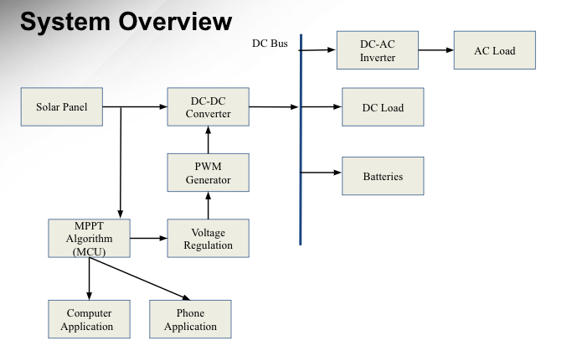

**Figure 2:** *Topology of Solar/Battery Power System*

# Operating Concept

## Scope

The solar/battery power system aims to provide a source of renewable energy, using solar energy to charge a laptop and a cell phone. The DC electricity generated by the solar panel flows through a DC-DC converter which acts to convert the variable input voltage (12-60 Vdc) to the desired output voltage (12 Vdc), while also charging a battery that will be used when not enough power is being produced by the solar panels. This ensures the charging of a device even when the sun is not present. A DC-AC inverter is used to convert the DC electricity (12Vdc) to AC electricity (110 Vac), allowing the use of the electrical grid. A MPPT algorithm will keep the PV system operating at the peak power point of the PV panel. It will also constantly record and send data to the backend database, which will be displayed through a website and android app.

## Operational Description and Constraints

This power grid system is intended for consumers to store and generate consumer usable power, carrying the ability to use stored power in situations where adequate power is not generated from the solar panel. This data can be presented to the user through a website and app as stated above. Listed below are the constraints for this system.

* The budget for the solar/battery power system is $400.
* The system must be able to tolerate outdoor temperatures from -15 degC to 50 degC.
* Must be placed in light to generate power, stored power will only last so long.
* The solar/battery power system is not portable.
* The grid can only handle so many loads.

## System Description

This solar power system will consist of four distinct subsystems; a max power point tracking system, a DC-DC converter, a DC-AC inverter, and a website/app. Detailed below is each subsystem and a short description of what they do and how they work.

* MPPT System - This subsystem regulates the power and voltage (PV) output between the solar panel and the battery. Specifically, it will consist of a microcontroller, current sensors, and voltage sensors to monitor the output of the solar panel, the battery charging, and the DC output. If the solar panel is not producing enough power the output will be switched to the battery.
* DC-DC Converter - This subsystem is dedicated to converting the input voltage to a desired output voltage. More specifically, the subsystem will draw altered voltage and current from the solar cells and decrease the voltage to 12V while reducing the current using a buck converter. Feedback will use the switch control and the MPPT system to ensure a stable output voltage is achieved. This system will also be multiphase to help transfer power.
* DC-AC Inverter - The inverter acts to regulate the flow of electrical power. It switches the direction of direct current (DC) electricity, which the solar panel generates, back and forth very rapidly, hence converting it to alternating current (AC) electricity, which allows use of the electrical grid.
* Android Application and Website - This subsystem includes a backend database. This database will be created using google Firebase, which will also host the website. The android application will be made using android studio, and the website and app will both use Angular. This subsystem will communicate with the ESP32 to receive data from the solar panel system. The data that is received and displayed includes the current and voltage from the solar panel, the harnessing pattern from the sun in Watts, if the system is in discharging or charging mode, the devices connected to the two outputs provided in the system, and the power level of the battery.
* Switch Control - This subsystem will control when the system will draw power from the solar cell or the battery. If the solar cell is not delivering sufficient power, this controller will switch the system such that power will be directly drawn from the battery.

## Modes of Operations

This power grid system will have two main modes of operation. The first of which is when the solar panel itself is generating enough energy to power the consumer devices connected to it. In this case, the MPPT will regulate the voltage and current to charge the battery with max efficiency. This altered voltage and current will go to the DC-DC converter which buck the voltage to 12V, which can charge a battery, power DC devices, or be converted to 110V 60Hz AC power using the inverter. Throughout this process, relevant voltage, current, and power data will be collected and sent to a database/website where it can be viewed by consumers.

The second mode of operation is if the solar panel does not provide enough energy to power the loads, typically at night. In this case, power is taken directly from the battery storage and converted to either 110V 60 Hz AC for AC devices or directly used for DC consumer devices. The same current, voltage, and power data collection occurs in this mode of operation as well, funneling into an app and website viewable by consumers.

## Users

Our product is marketed primarily towards consumers that have a need to generate their own power independently, or simply want to start using renewable energy for means of a cleaner environment. Consumers can purchase the system as is. It is able to power most if not all consumer products including phones and laptops.

## Support

A detailed user manual will be included with the system, providing information on how the system works, instructions for installation and usage, tips for maintenance, tolerances, and additional relevant information regarding the product. The manual will also provide a website in which users can track the voltage, current, and power generated by the system.

# Scenario(s)

***4.1. Charging Devices in Remote Locations***

The primary use of a solar/battery power system is to have access to electricity when there is limited access to electricity. Due to the large size of this device it can be used in remote locations where someone is stationary for a long amount of time. This device can also track the amount of power and voltage available to them, and track when the solar panels reach maximum capability. The system allows someone to charge their phone and laptop at the same time during the day as well as during the night.

***4.2. Easier Access to Renewable Energy***

The solar/battery power system is useful in any location given enough room for the solar panels to fit. This allows a person to generate their own energy within their home and connect many common household devices (within the specified range). The solar panels allow the battery to charge during the day, thus allowing for the use of the devices even with the absence of sunlight.

***4.3 Determining optimal solar panel positions***

The solar/battery power system can be used to determine the best location for solar panels. Homes and businesses, who may not be familiar with the sun's positioning, can measure and track how much power the solar panels produce everyday. This data will be easily accessible through both applications to make the most efficient use of the solar panels.

# Analysis

## Summary of Proposed Improvements

* The battery will be solar powered. Therefore, it will be a self sustaining system.
* The system will supply both an AC and DC source, allowing for the charge of small electronics including laptops, phones, etc.
* The output will change depending on the amount of light received by the solar panels.
* The battery will be charged when light is received by the solar panel and supply power when light is no longer detected.
* The website will display the voltage output of the solar panel throughout the day for the user to track the efficiency.

## Disadvantages and Limitations

There are some limitations in the design of the solar/battery system. These are listed below:

* Due to the given price range, the overall power output of the solar panel will be the main priority. This directly decreases the ability to purchase a more efficient solar panel that can produce the same output while being smaller in design.
* System can only charge with sufficient light levels.
* Power generated during sufficient light level hours will depend on how big the solar cell is.
* Battery power will only be able to run for a couple of hours due to budget constraints
* The output terminals will only have two different types of outlets.

## Alternatives

The solar/battery power system has some alternatives solutions, some are listed below:

* The solar/battery power system could instead switch to battery when there is no light instead of sufficient light. The trade off being that the system could absorb more power than it is producing under low light levels.
* The solar panel can be switched out for any type of generator as long as the voltage and current are reconfigured.
* A smartphone application is an alternative to the website/database.

## Impact

There are economic, environmental, social, and health impacts associated with the solar/battery power system as listed below:

* Economic Impact: The system uses solar power, therefore it would lessen the cost of electrical bills.
* Environmental and Sustainability: The system uses a renewable energy source therefore decreasing the use of oil/gas methods.
* Social: Easier access to using renewable energy because of the lower cost of only supplying power to small devices. It will provide a good starting point for communities that may not be able to afford a solar panel array to power a house.
* Health and safety: Producing power using the solar/battery power system is clean unlike most traditional generators. Owning and operating one of these systems will help battle pollution, a major health concern in this day and age.